International scientific conference
Truth and Compassion
Celje, Slovenia
November 5th–7th 2015
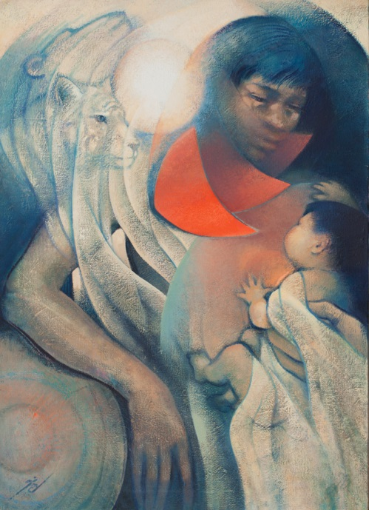
Author: Jaimie Cahlil
Title: Warrior of Truth and Compassion

Program
Thursday, November 5th
Arrival and accommodation of participants at Dom sv. Jožefa (Home St. Joseph, Spiritual Educational Center), Plečnikova 29, SI-3000 Celje, Slovenia
15.00-15.10 Welcome speech of the president of the organizing committee, Associate Professor Bojan Žalec
1
(Chairperson: Robert Petkovšek )
Lectures
15.15-15.45 Bojan Žalec (Slovenia): Either (Violent) Hypocrisy and (Self-)Deception, or Permissive Passivity: Is There a Third Way Possible?

15.45-16.00 Mark Kleyman (Russia): Am I Charlie? Religion, Truth and Tolerance in
Multicultural Urban Neighborhoods. (Video)
16.00-16.15 Tomaž Erzar (Slovenia): If We Are to Accept Pain, We'll Have to Cultivate Compassion
16.15-16.30 Mik Šetina (Slovenia): Compassion for Enemies as Necessity for Comprehension of Truth
16.30-17.00 Discussion
17.00-17.15 Break
2
(Chairperson: Branko Klun)
17.15-17.30 Vojko Strahovnik (Slovenia): Historical Truth and Integrity​
17.30-17.45 (Slovenia): Jože Dežman (Slovenia): Living in a Lie
17.45-18.00 Gábor Kovács (Hungary): ’It is Possible to Attain Truth through a Way Paved by Lies’ – The Historical Trajectory of Communism from Compassion and Truth-seeking to the Totalitarian Terror
18.00-18.30 Discussion
18.30 Meeting of participants
19.00 Dinner
Friday, November 6th
7.30 Mass in the Chapel
8.00-9.00 Breakfast
1
(Chairperson: Tomaž Erzar)
Lectures
9.30-9.45 Béla Mester (Hungary): Compassion with Other’s Pride – Addition for the Politics of Recognition
9.45-10.00 Robert Petkovšek (Slovenia): Demonic Violence, Lie and Truth
10.00-10.15 Stanislav Slatinek (Slovenia): Misuse of Truth in the Marriage and Its Fatal Consequences
10.15-10.45 Discussion
10.45-11.00 Break
2
(Chairperson: Bojan Žalec)
Lectures
11.00-11.15 Mateja Pevec Rozman (Slovenia): Truth and Compassion on the Horizon of Interpersonal Relationship and Personal Responsibility
11.15-11.30 Simon Malmenvall (Slovenia): Georges Florovsky and Russian Intellectual History: Rejection of Orthodoxy as a Way towards the Bolshevik Revolution?
11.30-11.45 Anton Jamnik (Slovenia): Truth and Compassion - Human Dignity, the Ethical Norm Should be Respected by All Persons
11.45-12.15 Discussion
13.00-14.30 Lunch
3
(Chairperson: Mateja Pevec Rozman)
Lectures
15.00-15.15 Roman Globokar (Slovenia): Truth and Compassion when Breaking Life’s Decision
15.15-15.30 Stanko Gerjolj (Slovenia): »He descended into hell«: Pedagogical and Psychological Dimension of Truth and Compassion
15.30-15.45 Marcin Godawa (Poland): Christian-Spiritual Way Out of Anthropological Compassion Trap
15.45-16.15 Discussion
16.15-18.00 Visit of city Celje
19.00 Dinner
Saturday, November 7th
7.30 Mass in the Chapel
8.00-9.00 Breakfast
1
(Chairperson: Stanko Gerjolj)
Lectures
9.30-9.45 Neja Samar Brenčič (Slovenia): Social Exclusion and Suicide in the Elderly Population
9.45-10.00 Branko Klun (Slovenia): Love and Truthfulness in Marion’s The Erotic Phenomenon
10.00-10.15 Tadej Strehovec (Slovenia): The Truth, Guilt and Belief in the Context of Secularization
10.15-10.45 Discussion
10.45-11.00 A concluding word of the president of the organizing committee Associate Professor Bojan Žalec
12.00-14.00 Lunch
14.00 Departure of participants

